# **42. SSH (Secure Shell)**

## **Console Port Security**

* By default, no password is needed to access the CLI of a Cisco IOS device via the **console port**.
* You can configure a **password** on the *console line*, requiring users to enter a password to access the CLI via the console port.  
    
   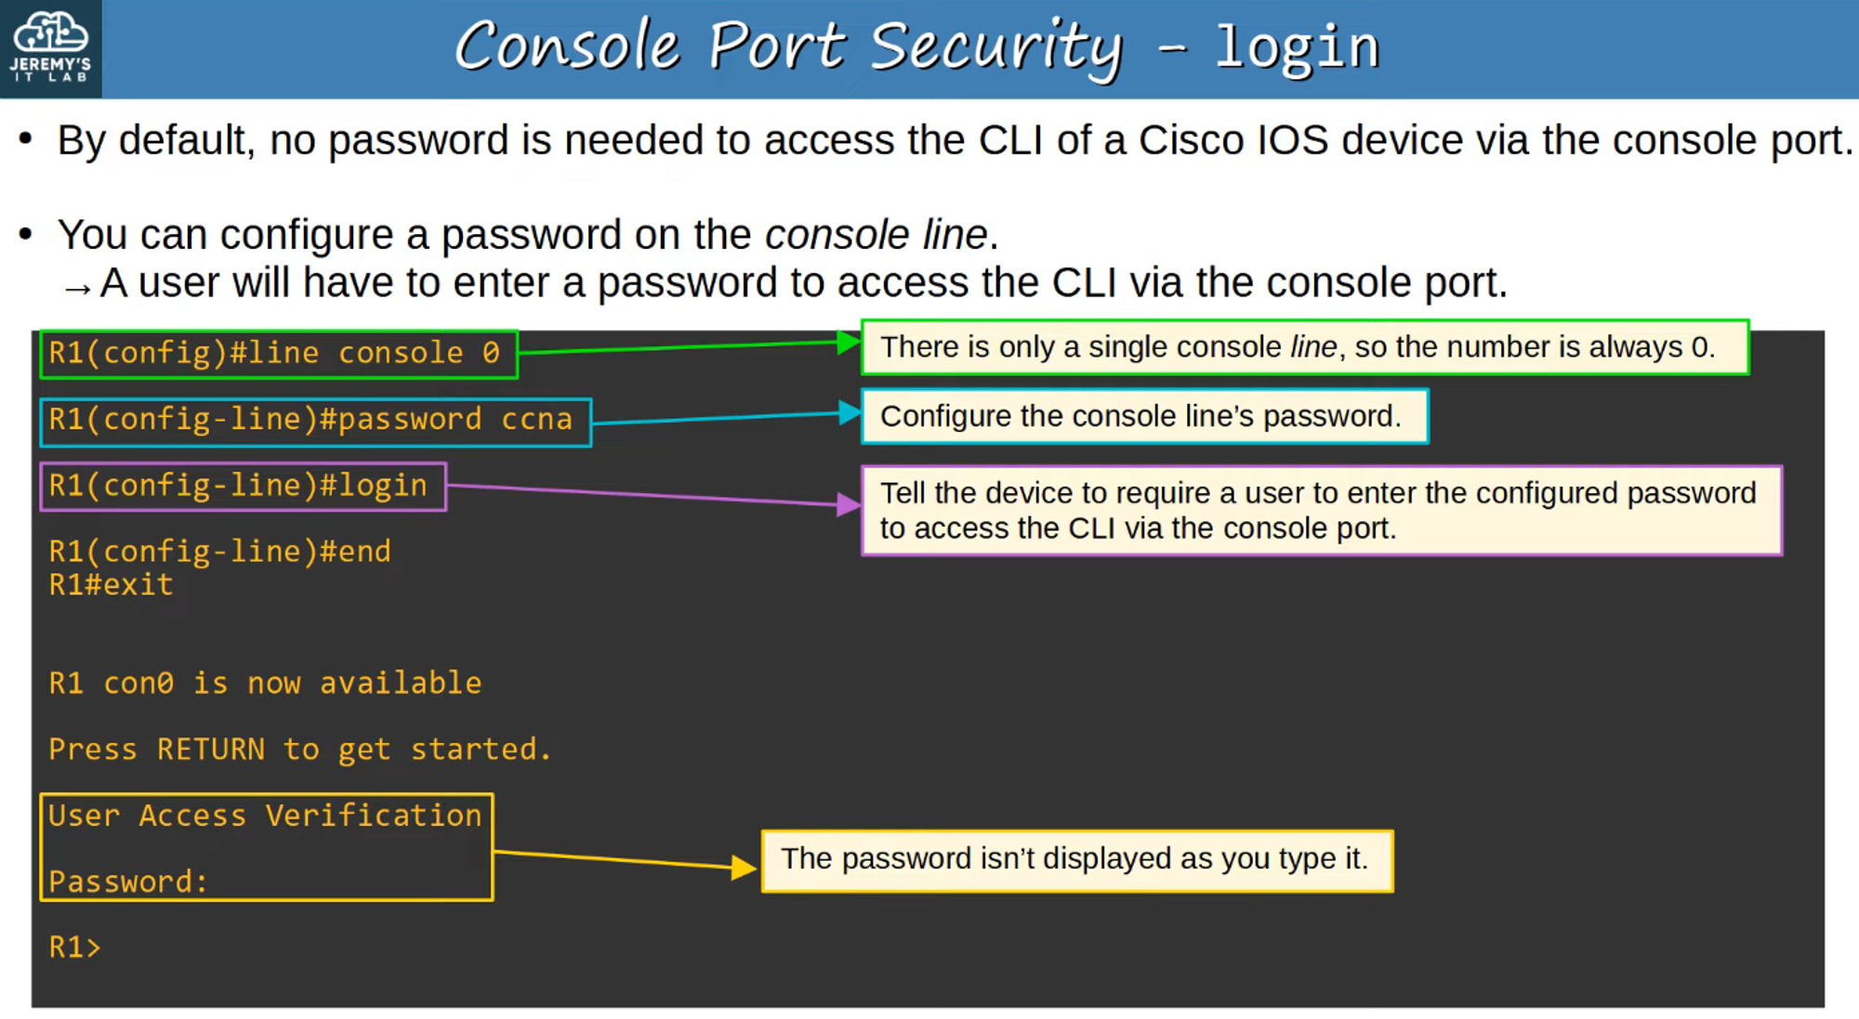
* Alternatively, you can configure the **console line** to require users to log in using one of the **configured usernames** on the device.  
    
   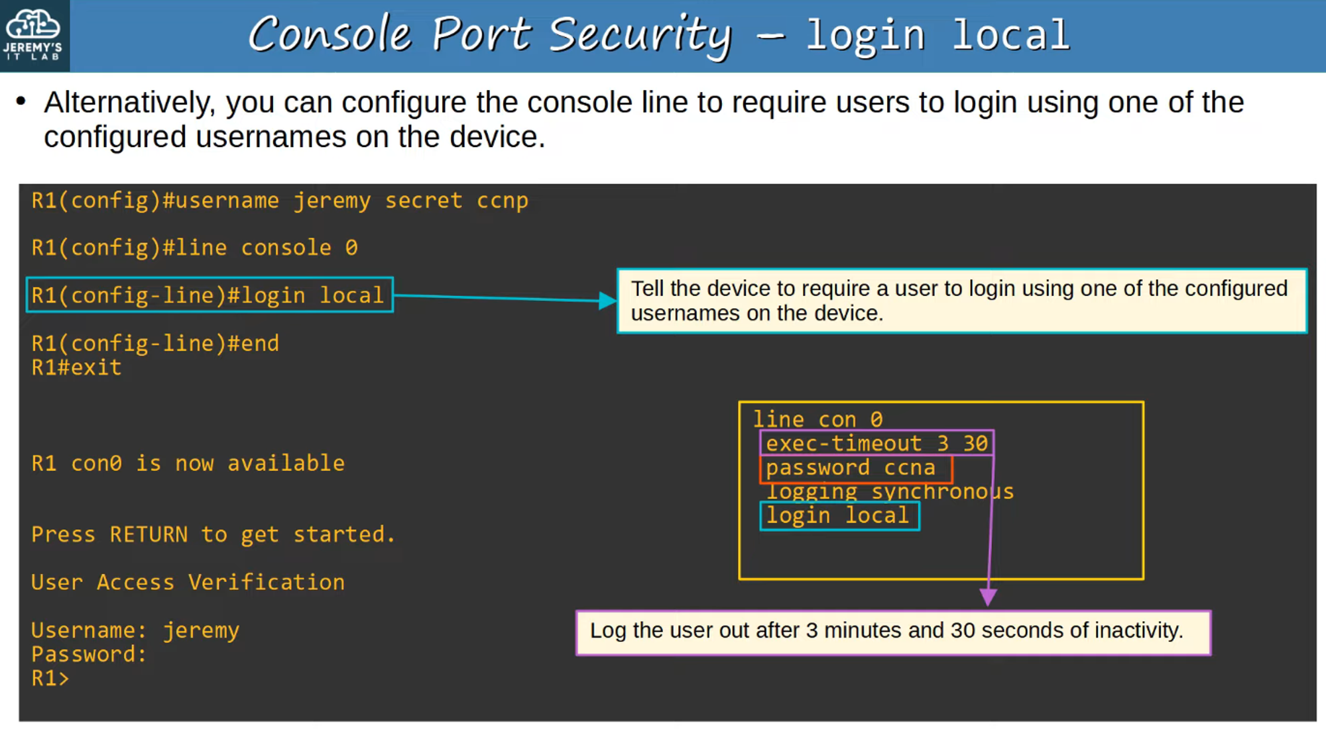

## **Layer 2 Switch Management IP**

* **Layer 2 switches** do not perform **packet routing** or build a **routing table**. They are **not IP routing-aware**.
* However, you **can** assign an **IP address** to an **SVI (Switch Virtual Interface)** to allow **remote connections** to the CLI of the switch (using Telnet or SSH).  
    
   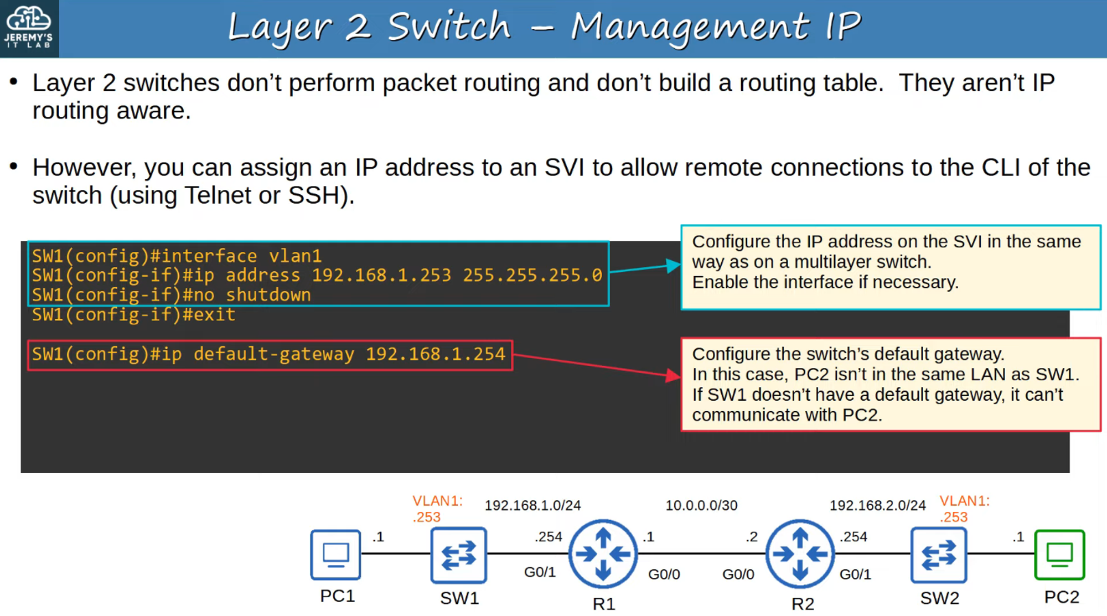

## **Telnet**

* **Telnet (Teletype Network)** is a protocol used to **remotely access** the CLI of a remote host.
* Developed in **1969**, Telnet has been largely **replaced** by **SSH**, which is **more secure**.
* **Telnet sends data in plain text—NO encryption!**

💡 **Telnet servers listen for Telnet traffic on TCP port 23.**

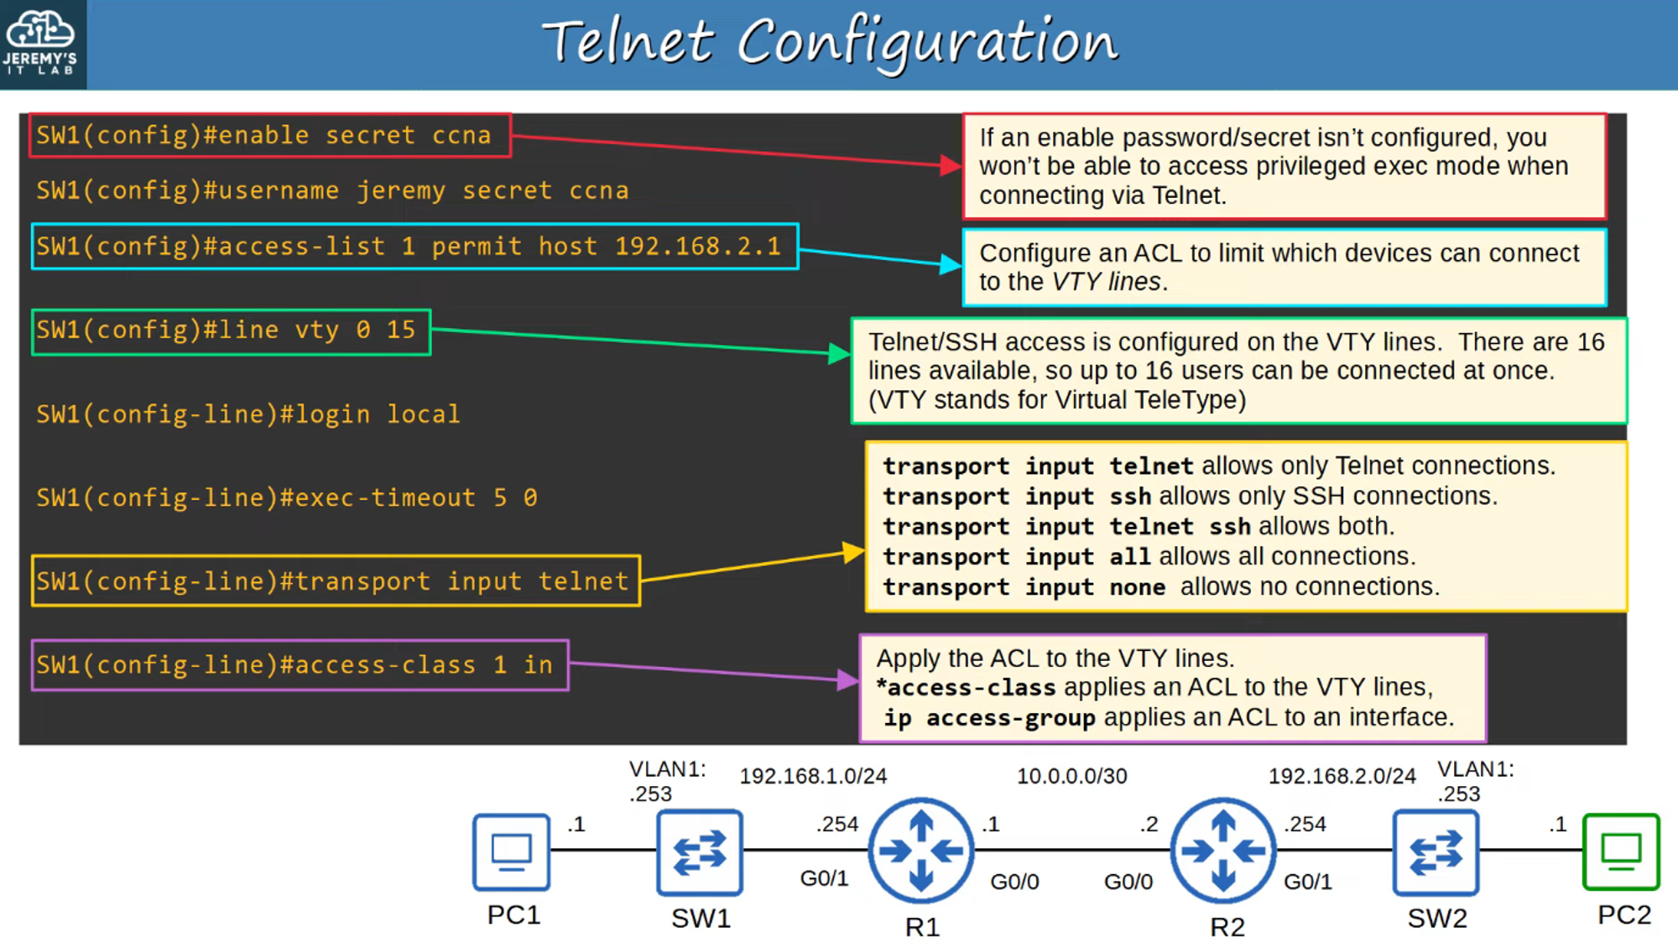

## **Verify Telnet Configuration**

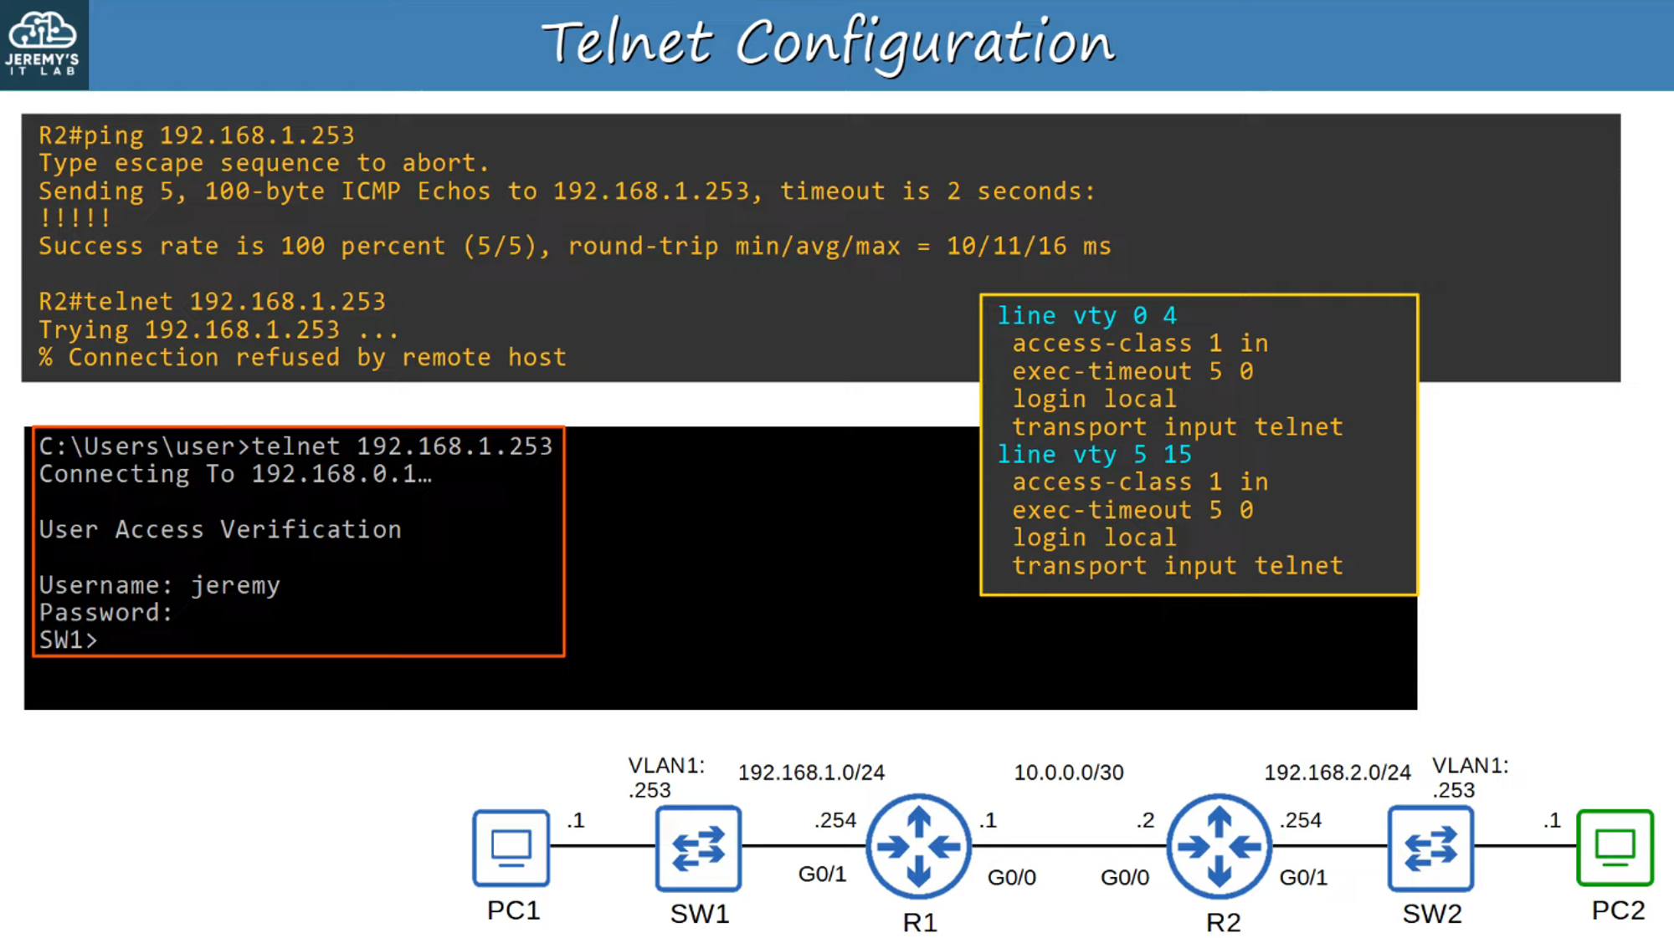

## **SSH (Secure Shell)**

* **SSH** was developed in **1995** to replace **less secure protocols** like Telnet.
* **SSHv2**, a major revision of **SSHv1**, was released in **2006**.
* If a device supports both **v1** and **v2**, it is said to run **version 1.99**.
* **SSH provides security features**, such as **data encryption** and **authentication**.

### **Check SSH Support**

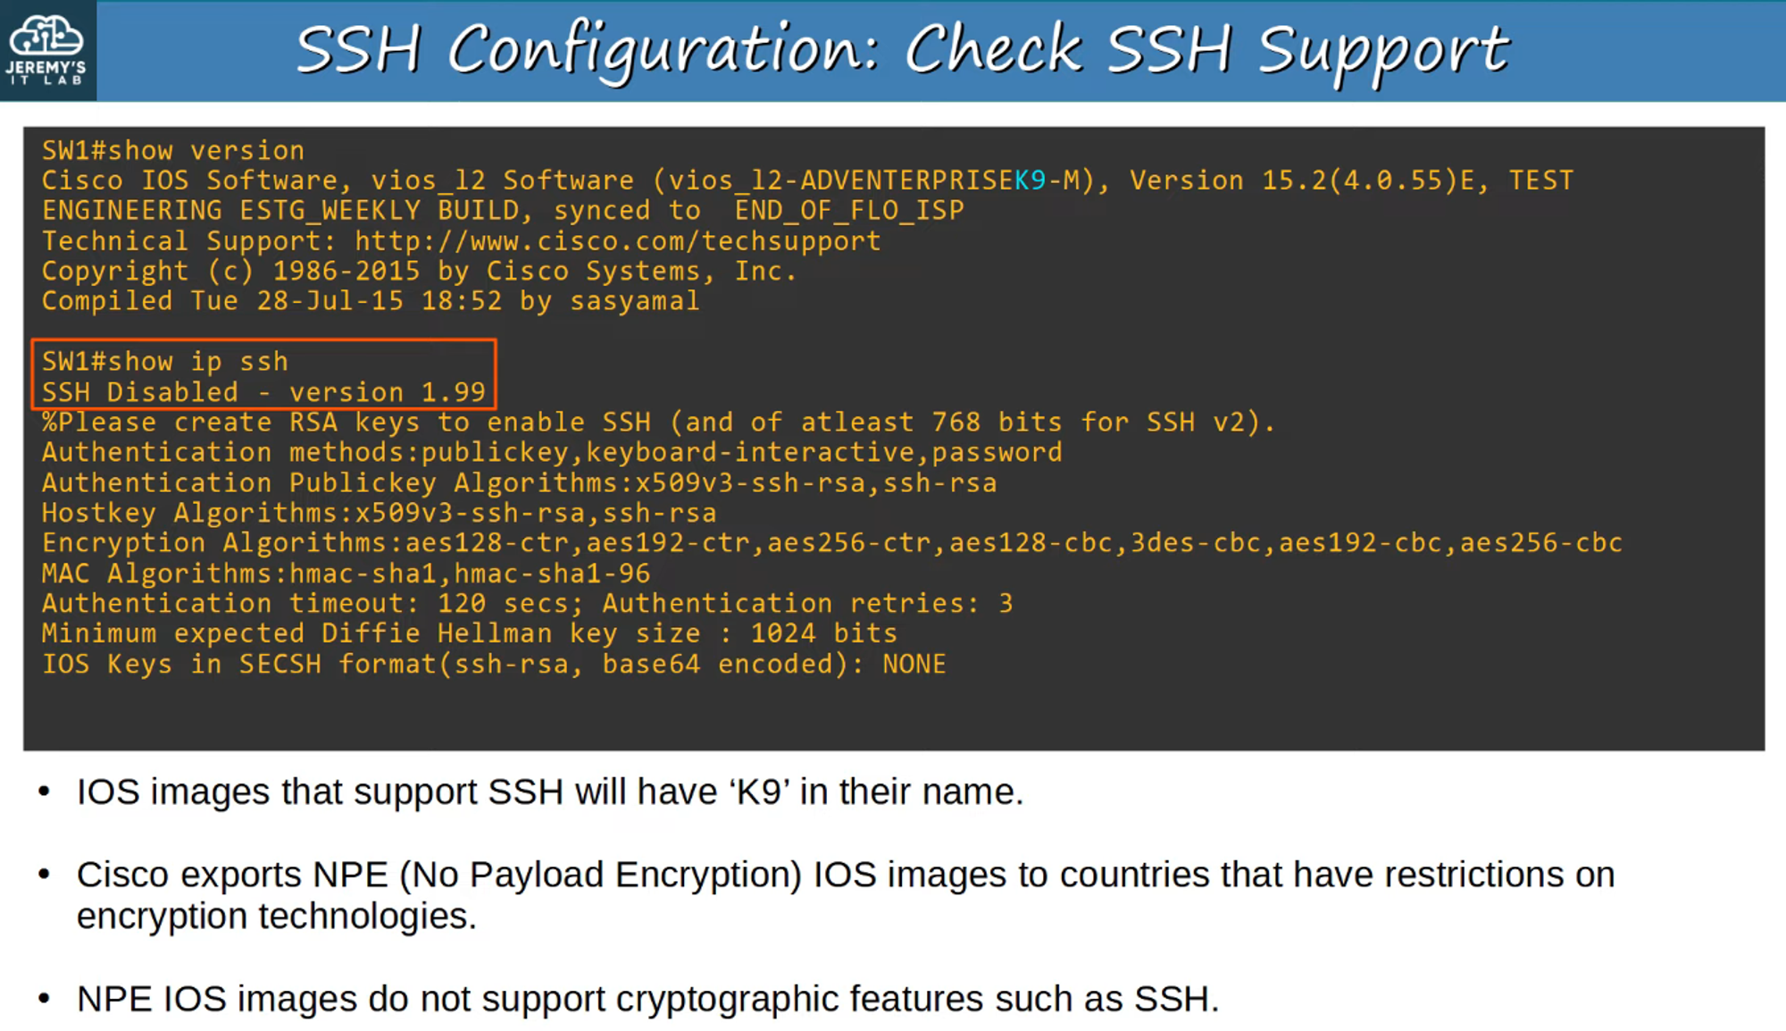

## **RSA Keys**

* To **enable and use SSH**, you must first generate an **RSA public and private key pair**.
* These keys are used for **data encryption, decryption, and authentication**.  
    
   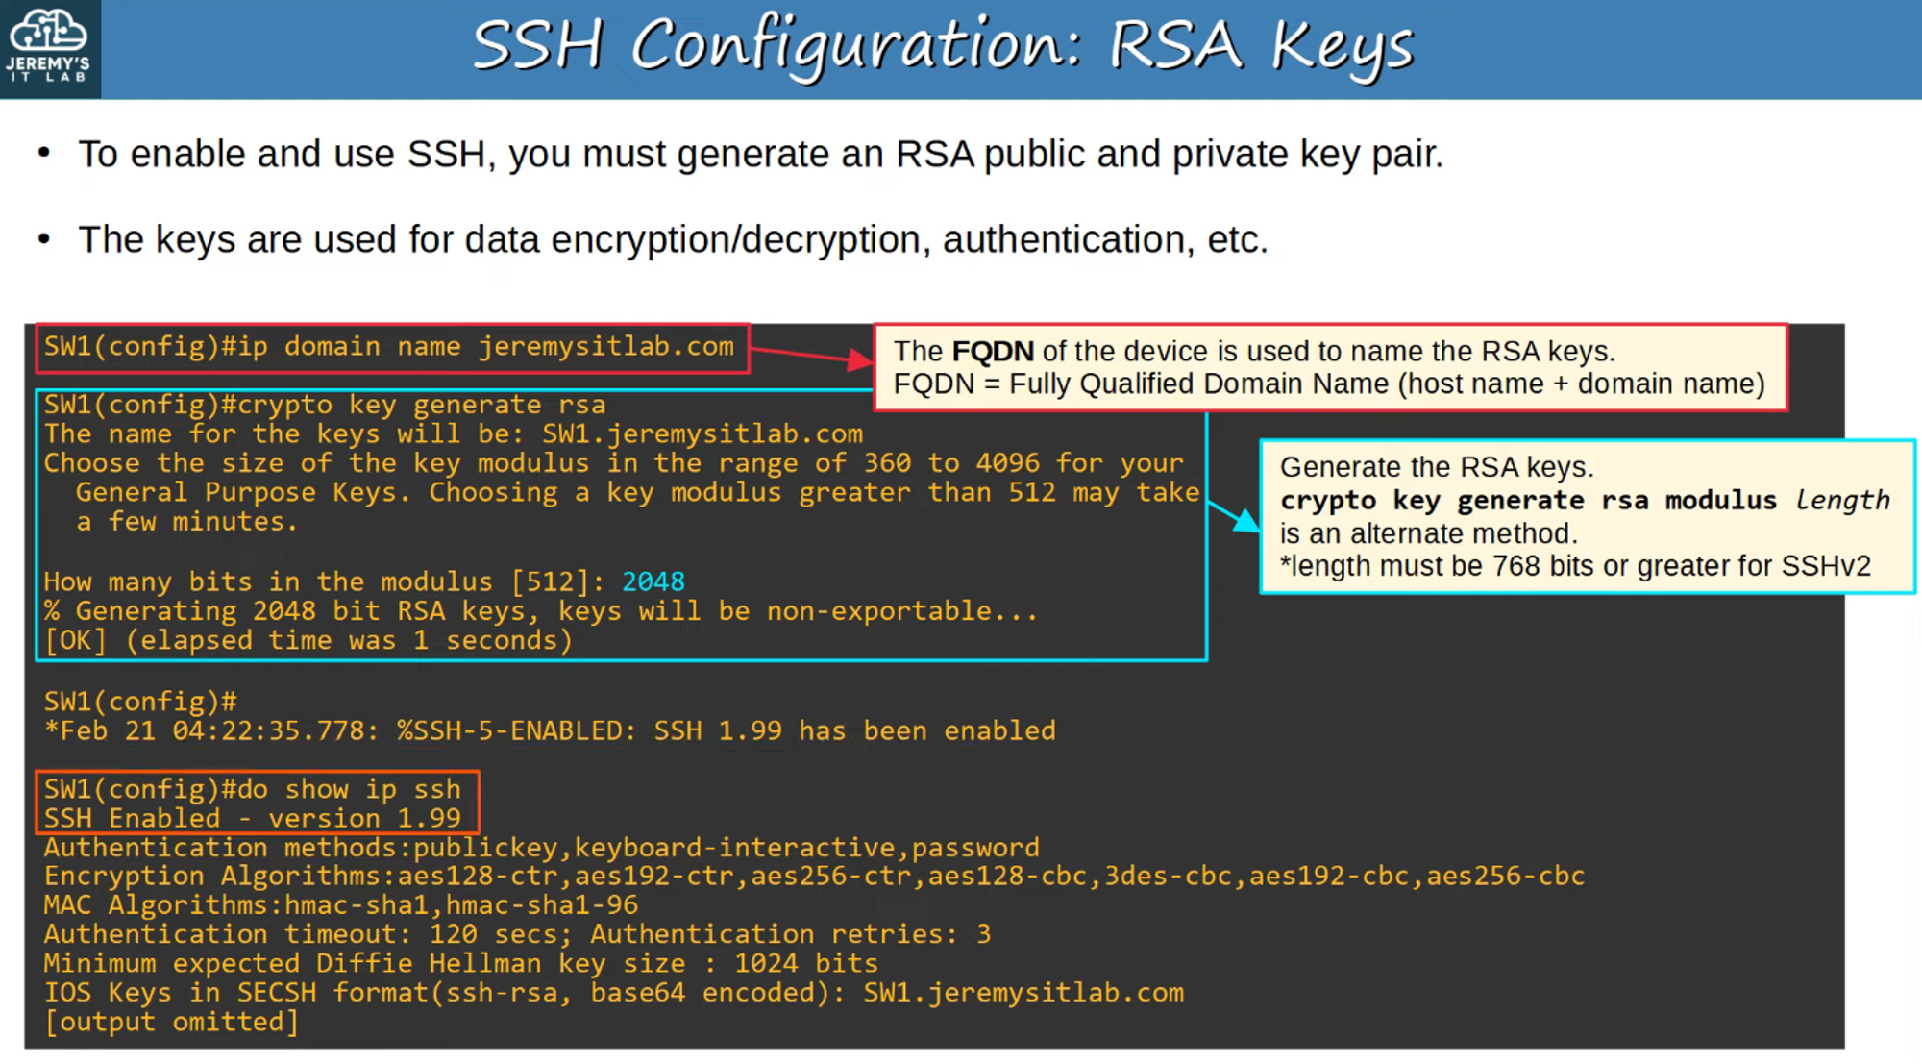

## **VTY Lines**

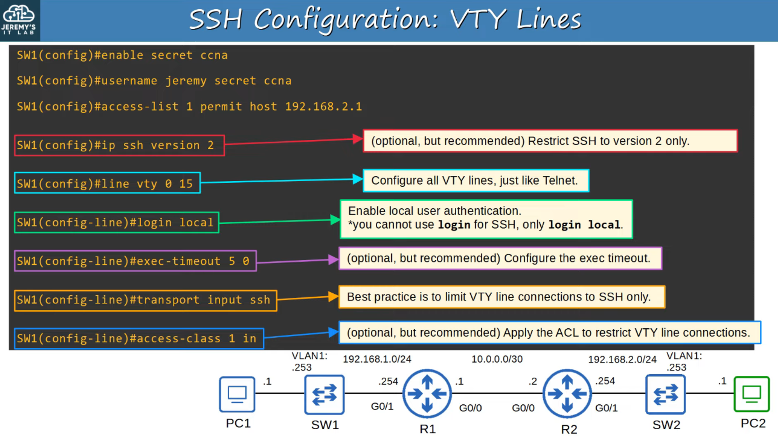

## **Summary of SSH Configurations**

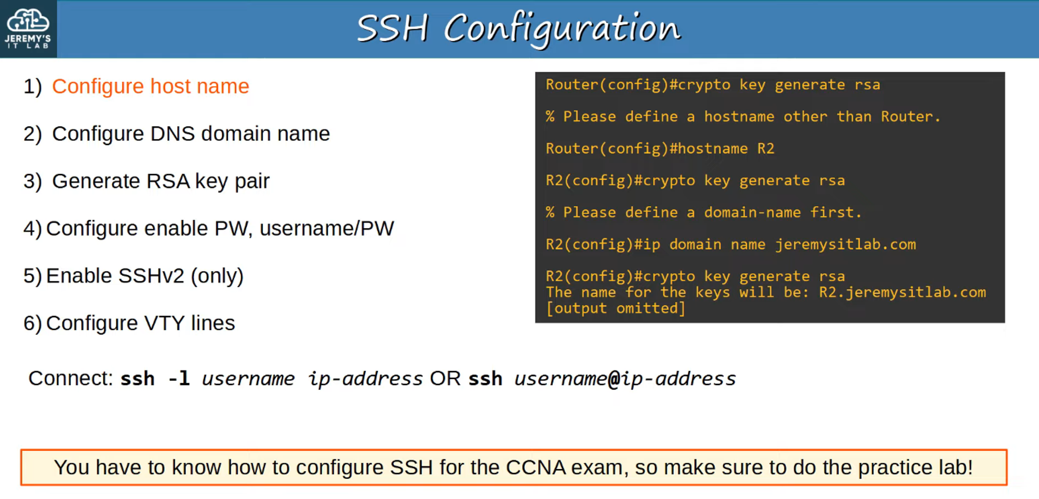 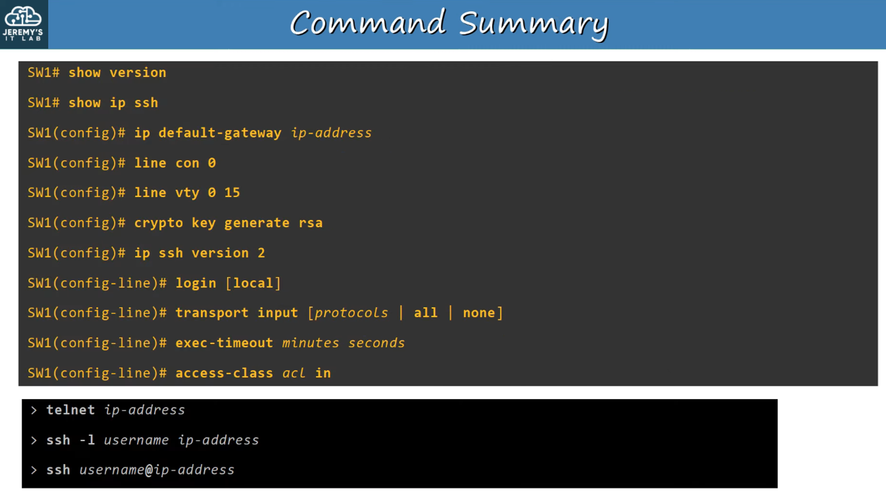

Make sure to practice Configuring Telnet/SSH